ASSIGNMENT 7

# COMPILER DESIGN LAB

NAME: Parv Gupta

SAP ID: 500105033

BATCH 5

## WAP to implement a Predictive Parser for a given language in C

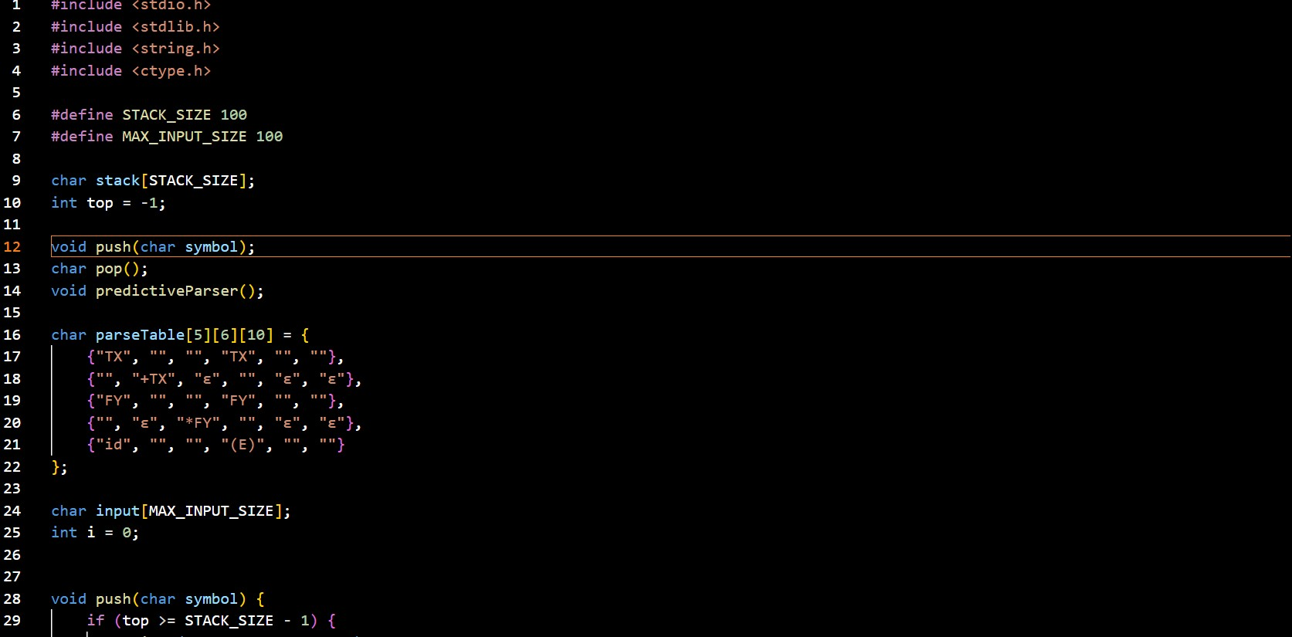

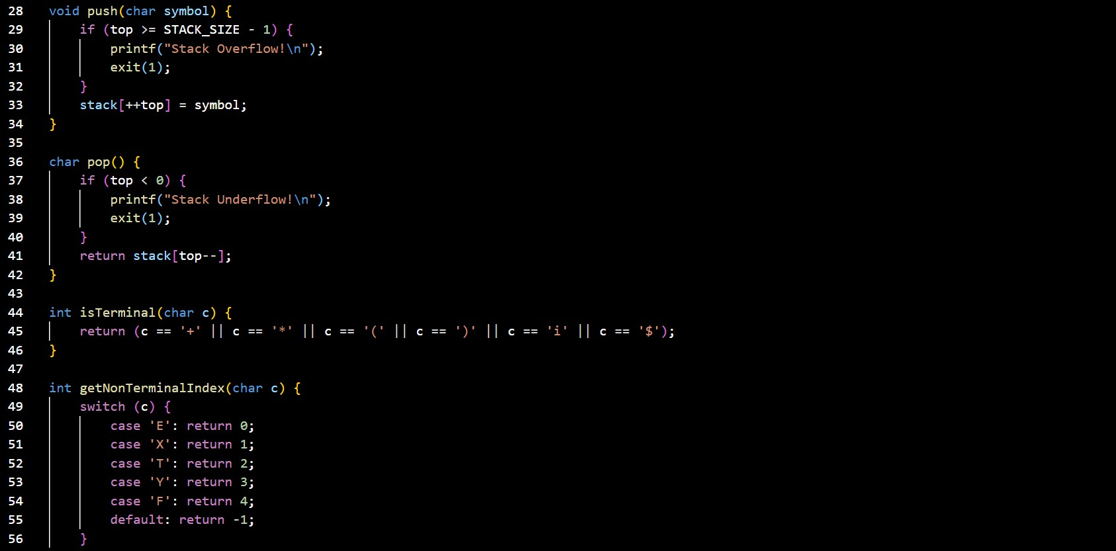

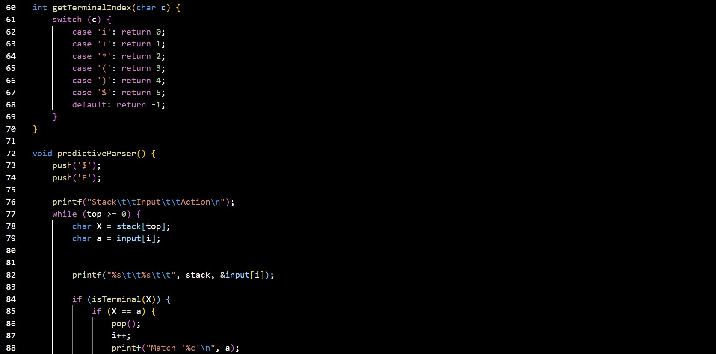

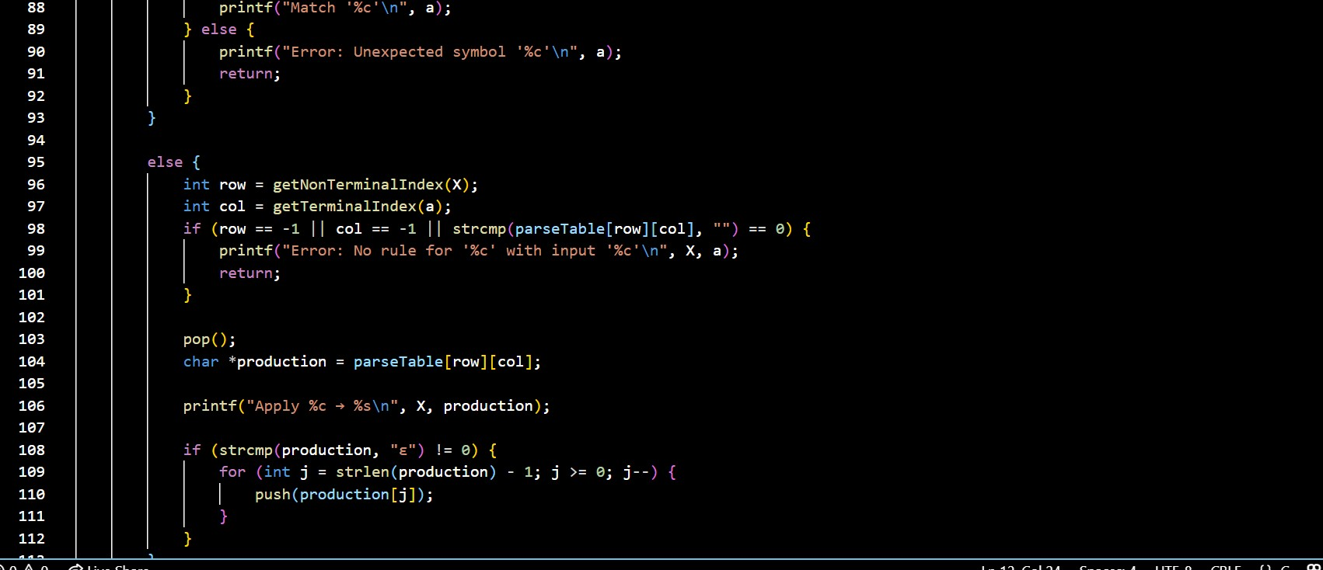

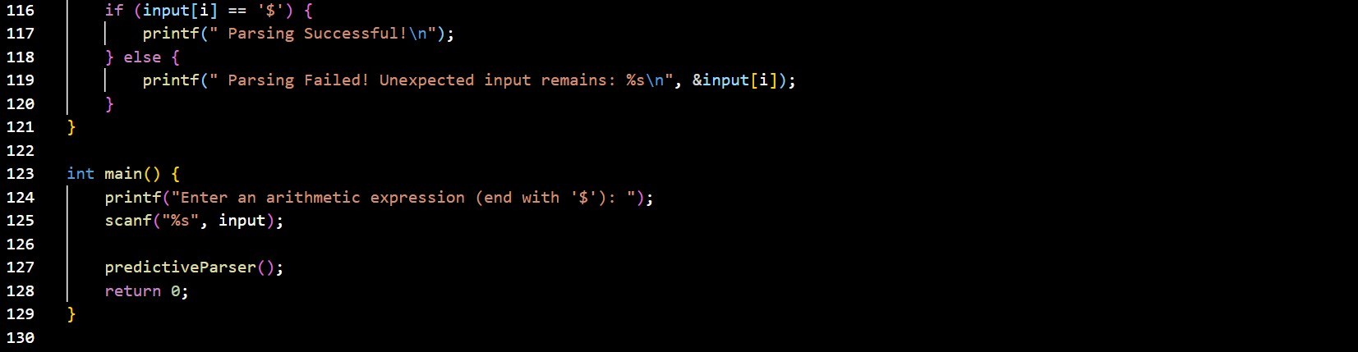

## **OUTPUT**

